Area F 2017 Field Report
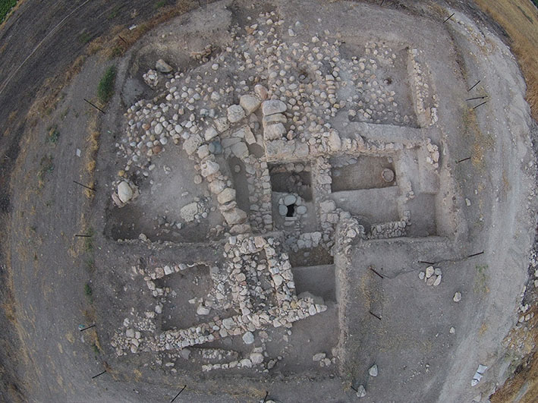

Area F was excavated for two weeks in the 2017 season, concentrating on the goal of exploring the stone feature in Square R/5 that was revealed in the previous season. Excavation took place in this square around this feature, continuing into the north balk of the square. Square Q/5 was also excavated, concentrating on revealing the context of the large tabun found in the previous season. In addition, the balk between Squares Q5 and 6 was removed down to the top of the MBII fortification (Wall 1327). Ortal Haroch was the supervisor, assisted by Dianne Benton.

Square R/5
Stone Installation 4313
The top of a stone structure of more or less rounded contour of large stone and covered by a few flat stone slabs, was revealed in the previous season of excavation. It is bordered by Wall 2377 on the east, Wall 4307 on the south and Wall 2320 on the west. On the north, Iron I Silo 1374 cut into northwestern corner of the layer abutting the stone installation and a concentration of stones just to its north appears to be a wall (Wall 5309), although its contour is slightly rounded. Pit/Favissa 4314 abutted the southwestern side of this feature, but it did not seem to have cut it.
The diameter of the top/rim of the installation is 1 m, and upon removal of the stone slabs that covered it, an opening ca. .60 m in diameter was revealed. Excavation into the matrix inside the installation yielded an accumulation of soft silty brown soil that was virtually sterile, aside from one cooking pot rim (LB?). The rounded walls of the installation were built with the technique of corbelling and were very sturdily constructed. No signs of plaster were detected. In the northern side of the wall was an opening, slightly trapezoid in shape and ca. 30 cm wide on its top, that was capped on top by a rectangular stone. Excavation to the north of this stone revealed several additional stones that serve as the capping of a channel that fed into the feature. It seems most likely that this was an inlet and not an outlet, based on the assumption that whatever drained into the installation, came from inside the city, which was to the north. Excavation proceeded down inside the installation (Locus 5311) to a depth of ca. 80 cm, when it became impossible to continue. Samples of the soil were taken for analysis.
Room in which stone installation 4313 (before removal of capstone) is set: Wall 5309 on the north, Wall 2377 on the east and Wall 2320/4308 on the west; looking north. Silo 1374 (eastern half excavated away) cutting and overlying corner of Walls 2320/4308 and 5309.
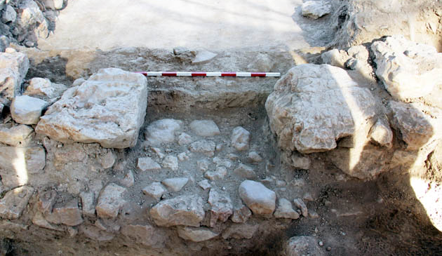
Left: Same as previous photo, looking west; black heart marks location of Iron I favissa pit; note entranceway in Wall 4308/2302 leading to “tabun room”; right: detail of entrance leading to tabun room
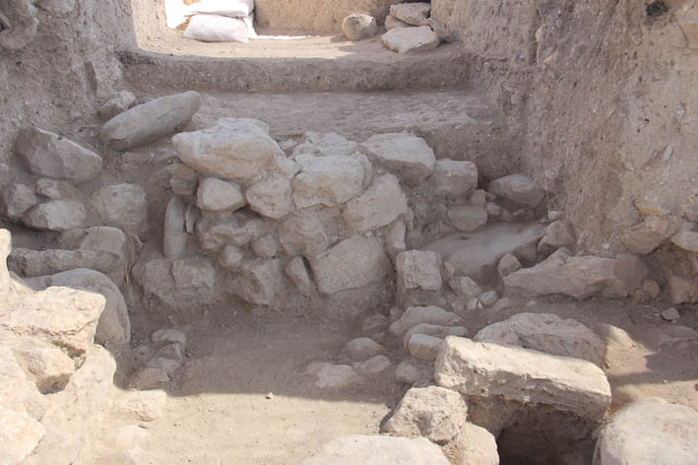Looking north at Wall 5309 and the opening of the channel inside the installation
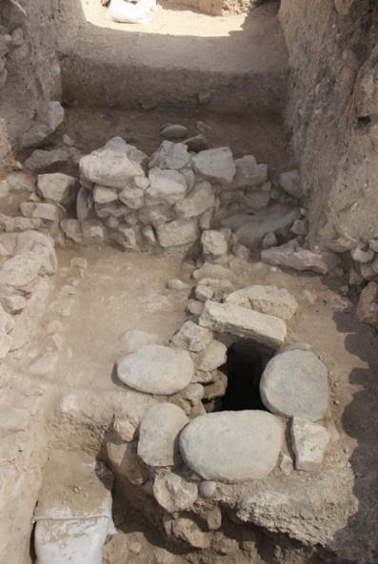Installation 4313, after removal of flat capstones; rectangular stones on top of channel; looking north (Wall 5309 to north).
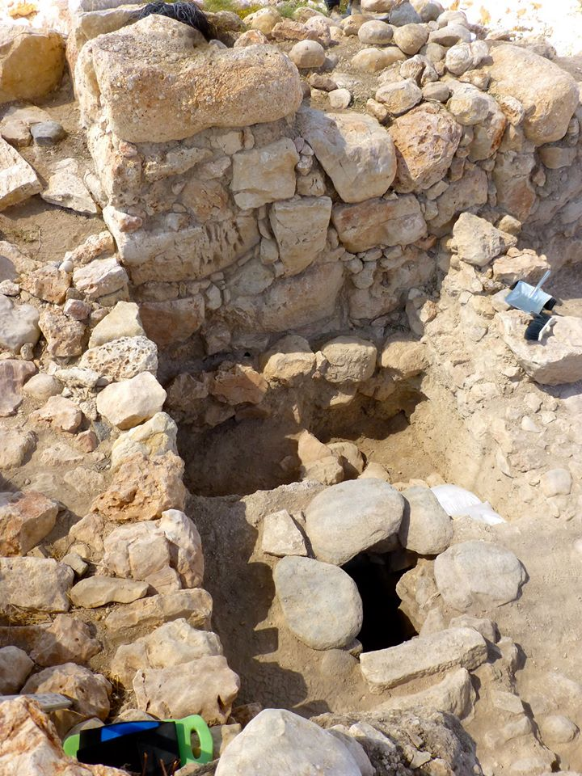Installation 4313 after removal of capstones and excavation inside, looking south; note rectangular capstone of feeding channel.

Excavation north of Wall 5309 in a small area reached a layer with an almost-complete cooking pot and a quatrefoil bowl (marked by arrow in photo below). These vessels date the context to the transitional MB-LB phase.
The location of this installation inside a well-built room, one of whose walls is the northern face of the MBIIB fortification, is curious. The installation is fed from the north but has no outlet to the south, where one might expect the contents to be drained (i.e., outside the city). If indeed the goal was to drain some substance (sewage? Rainwater?) to outside the city, this installation would have had to penetrate down to below the foundation of the MBIIB fortification (a level we have not yet reached). Another curious feature is that the entrance in the western wall of this room leads into a room that contained a large and well-built oven (see below), as well as a baby-burial storage jar under the floor. One possibility is that the installation is earlier than this room, and another is that it is later and penetrated into the room. The evidence for both these possibilities is slim; a layer of whitish plaster that abuts Wall 2377 (the eastern wall) also seems to abut the upper stones (rim) of the installation and no sign of it being cut or covering the top was noted. Further excavation is required to better understand this feature.
View of Squares R/4-5; looking northeast. Iron I building above layer of fill and LB accumulation above room with installation 4313.
Square Q/5
“Tabun Room”
To the west of the room with stone installation 4313, an entranceway led into a space that is bordered on the south (as is the room with the stone installation) by the northern wall of the MBIIB fortification. Thus, the eastern border of this room is Wall 4308/2302. The northern and western walls were not revealed and lay below and beyond the LB and Iron Age walls that have not yet been removed. An oven (4317) composed of a very large cooking pot surrounded by tabun-like material was sunk into the floor on the western end of this space (against a subsidiary balk). Its rim and upper part protruded above floor level and it was surrounded by ash. The floor associated with this level (4315) was composed of hard beaten earth with some ashy patches. Below it was a layer of soft debris (5312) in which a row of stones bordering a gravelly layer was found (5309), in the corner between Wall 1327 (the northern wall of the fortification) and Wall 4308. Due to these stones, the locus was changed to 5314 and it was considered that this was a floor due to the exposure of the top of a storage jar burial in it (the layer around the jar itself was designated 5316 but not excavated to any depth; the jar burial remained unexcavated). However, it is not certain that this represents a lower floor, as the matrix did not change very much from the soft debris of 5312. The function of stones 5309 and the gravelly layer to their south (up until the face of Wall 1327) is not clear; if 5314 is a surface then they possibly they served as a kind of bench or low platform. Alternatively, the stones are related in some way to the burial and all of these features are below floor 4315, but related to that occupation. The northern end of stones 5309 seem to penetrate under the foundation of Wall 4308 to its east, but this is not yet clear and it is more likely that the three elements: 4308, 5309 and Wall 3127, are contemporary. Thus, three possibilities exist: 1-the floor level that goes with the entranceway in Wall 2302/4308 led to a floor that is later than the oven; 2-the floor with the oven (which is sunk into it) is associated with Wall 2302/4308 and the entranceway in that wall. In this case, the layer below the floor of the tabun with stones 5309 and the jar burial are sub-floor elements and are related to it; perhaps the stones are a marker for this burial; 3-there are two floors, the uppermost one phased with Wall 2302/4308 and the oven, and the lower one, with the stones, phased earlier than these elements and below that floor is the burial. Based on the present evidence, it seems that possibility 2 is preferable, but the first one must be considered as well.
The cooking pot is of the type characteristic of the transition between MB-LB, with a flaring rim and an incised decoration on its carination. It is presently being restored.
Left: rim and neck of oven removed; note tabun material surrounding it; Right: cooking pot/oven after excavation to its base. Wall 1327 is the northern wall of the MBII fortification.
Entrance in Wall 4308/2302, stone installation room on the left (east) and tabun room on the right (west); looking south at Wall 1327 of the MBII fortification. Arrow points to storage jar burial.

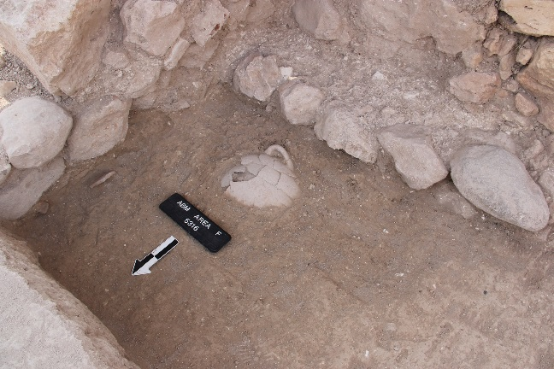Corner of Wall 1327and 4308 with stones 5309 in it and storage jar burial just north of 5309. Looking southeast.

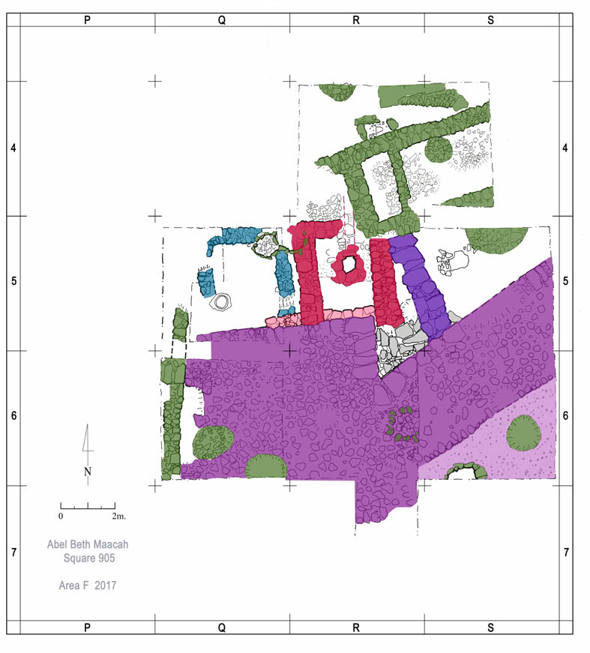
Superposition of strata, end of 2017; Dark and light purple: MBIIB; Red and pink: LBI; purple-blue: LBIIA; blue: LBIIB; green: Iron I; light gray stones possibly related to LBIIA wall; these are stone slabs in secondary use and they cut the southern end of the ‘red’ wall of LBI.

