Field Report
Area O 2019

Two weeks of excavation took place in Area O in the 2019 season. The area was supervised by JP Dessel and the registrar was Michelle Ginsberg. Excavation concentrated in the western squares (H/12 and I/12) with the goal of reaching the Early Bronze Age occupation that we assume exists here. This goal was not accomplished, as a layer with numerous MBIIB burials was reached in H/12.
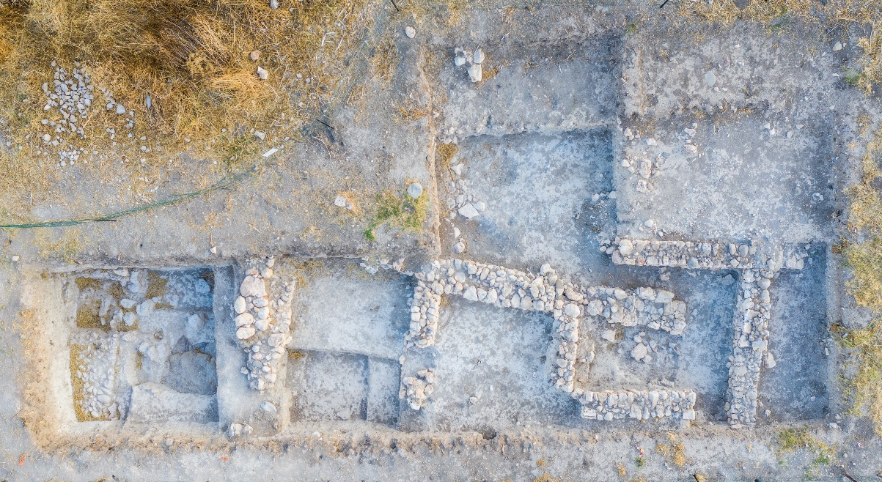
Area O, aerial photo – end of 2019
Square H/12
Following cleanup, as the area had not been excavated since 2014, excavation proceeded to the east and west of Stratum O3 Wall 2510 which was floating at the end of 2014. Since the area to the east of the wall was excavated to a lower level in the northern part, the area was divided into two in order to level off the higher southern part. To begin with, two cleanup loci were opened: Locus 7501 in the north and 7503 in the southern (higher) part. Upon reaching the 2014 level in the north (=Locus 2542), the southern part was excavated as 7505 in order to level it off. This locus = the continuation of 2524 of the 2014 season.
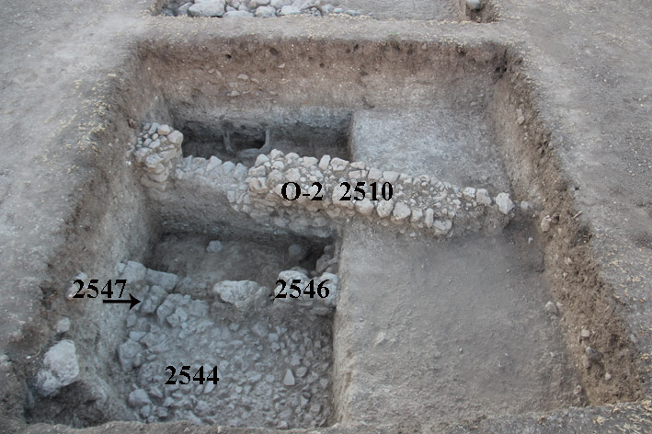
Square H/12, end of 2014 – looking east.

West of (floating) Wall 2510
To the west of Wall 2510, the southwestern quadrant, which was left on a higher level in 2014, was excavated as 7502 (cleanup) and 7506 (=Locus 2538 from 2014). The narrow strip between Wall 2537 (see below) and Wall 2510 was designated 7507 (=2539 from 2014). The northwest-southeast row of stones designated Wall 2537 in 2014 was clarified and was found to have been a burial marker (burials described below). Wall 2547, a segment of a wall that had been revealed below the northern part of Wall 2537 in 2014, was also clarified and is understood to be part of Wall 2537, at least functionally, as it also probably marked this burial ground in some way. In 2014, a jar burial was found below Wall 2537 and above/abutting the northern end of Wall 2547, that is most likely part of this very same burial ground. Since cobblestone layer (floor?) 2544 (along the entire western end of the square; its southern part was revealed in 2019 under debris 7506), abuts the western face of Wall 2547, it should also be phased together with the wall and probably have served the purpose of a burial grounds’ marker, or partition wall, as well. Excavation below its northern end (Loci 7526, 7527) showed that it indeed is only one layer deep (as opposed to our hypothesis in 2014 that it might be the top of a wide wall that continues down). In addition, the small segment of an east-west wall, 2546, poorly preserved and probably having cornered with 2547, was most likely also part of this system of burial-marker walls. All these walls (2537, 2546, 2547) were removed this season.
Wall 2510 was dismantled (5/7/2019) and excavation on both its sides was joined. Below the wall was a layer of fill – 7508 – that also covered the burials which were found clearly underneath the wall.
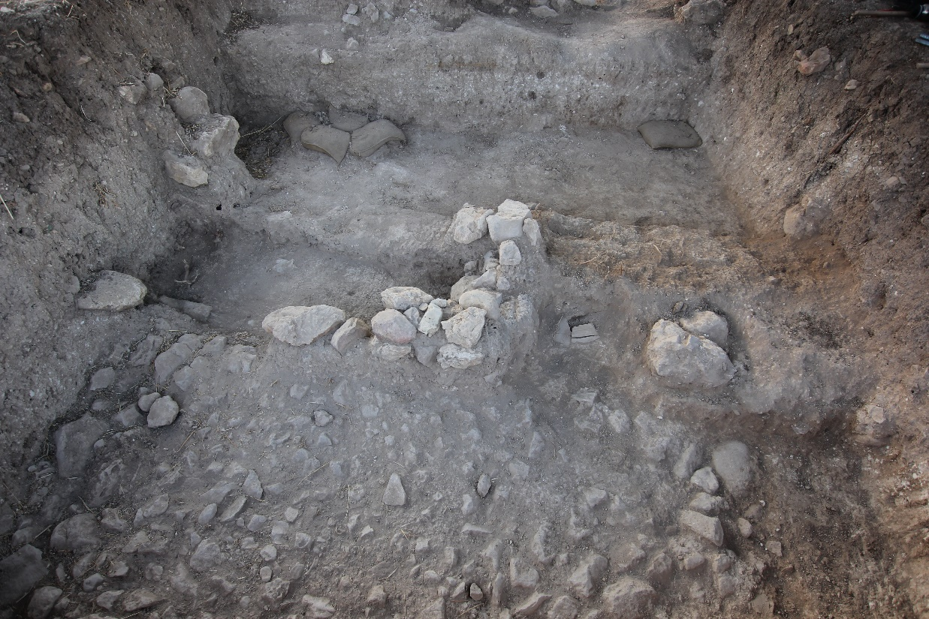
ABM19-O-002. Square H/12 after dismantling Wall 2508, looking east. Center: east-west Wall 2546/7510. Cobblestones 2544 in foreground.

All the elements below Wall 2510 are attributed to Stratum O3. Including the burials revealed this season that are below and/or associated with the elements excavated in 2014 to the west of this wall.
East of (floating) Wall 2510
Excavation at the end of 2014 reached a surface – 2542 – at 365.42 m. It was composed of hard packed dark brown earth and a related installation (pithos?)/tabun that protruded from the eastern balk – 2545 –was revealed but not excavated. Excavation this season in this narrow area, between floating Wall 2510 and the eastern balk, first levelled off the higher section left in the south, excavated as Locus 7505 (=2014 Locus 2524). Excavation of Installation 2545 after removal of the grindstone that was placed in it showed that it was composed of two parts: a tabun-like ring surrounding a jar that is embedded in the eastern balk, with traces of ash inside. The possibility that this is yet another jar burial was considered, although the ash and ‘parapet’ surrounding it are unclear.
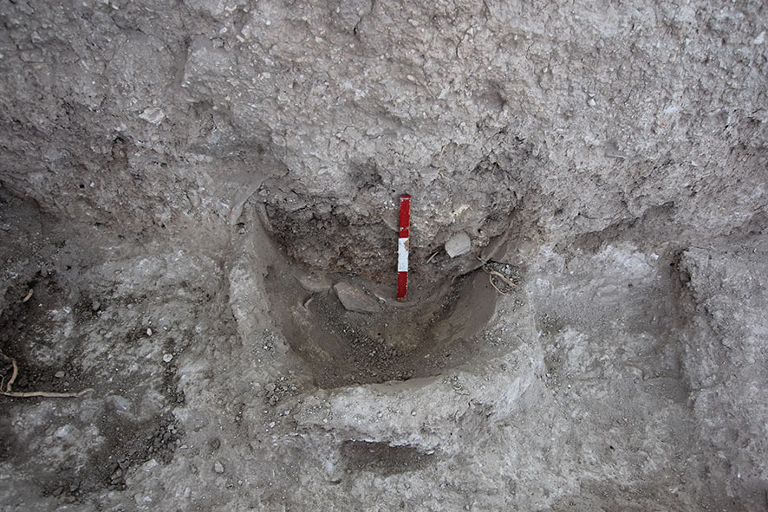
AMB19-O-049. Square H/12, looking east at Installation/tabun 2545 in the eastern balk. Note ring of tabun-like material with jar with ash inside it.

The Burial Ground
With the removal of Wall 2510, the eastern and western parts of the square were joined and the burials were excavated as one layer: 7508/7515 in the northeastern part of the square, 7509 in the central-eastern and southeastern part of the square, 7514 in the northwestern part (east of stones 2544). The line of east-west stones designated Wall 2546 in 2014 became clear after Wall 2510 was dismantled and were designated Wall 7510, found just to the north of pithos burial 7510.
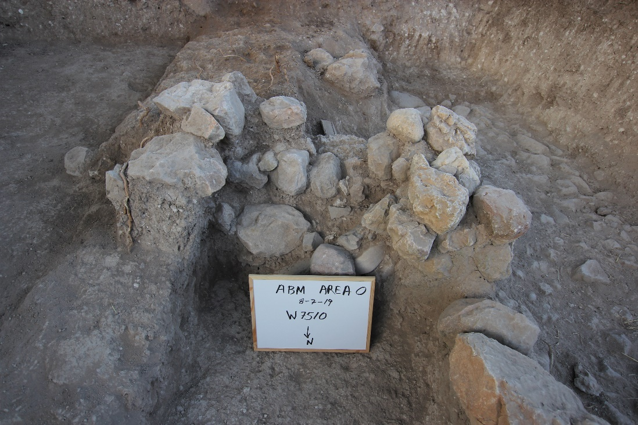
ABM19-O-014. Wall 7510 in center of square, looking south.

Four burials were revealed:
1-Pithos burial 7513: large pithos, lacking neck, base in the north near Wall 7510, location marked by bowl; containing three toddler skulls and other bones, two piriform juglets; MBIIB
2-Jar burial 7516: just west of pithos burial 7513, partially located on the eastern edge of cobblestones 2544, bones disintegrated.
4-Pithos burial 7522 – southeast quadrant of square (not excavated)
Skull (adult) 7524
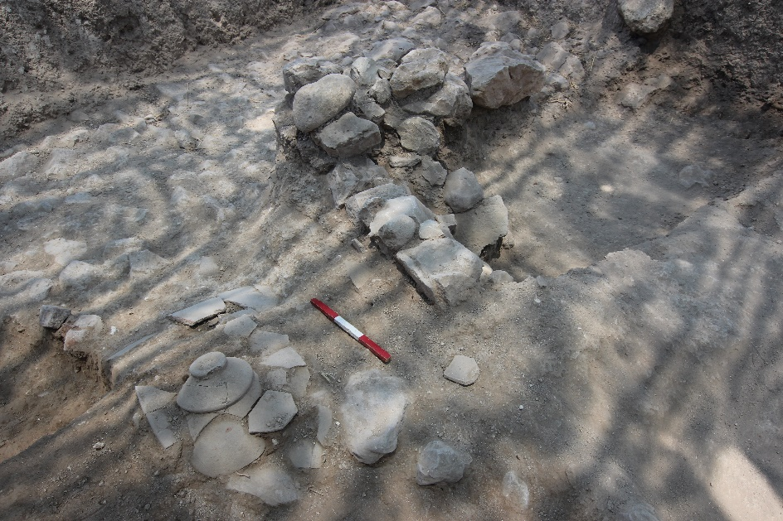
ABM19-O-025. Square H/12, looking northwest; bowl marking top of pithos burial 7513,
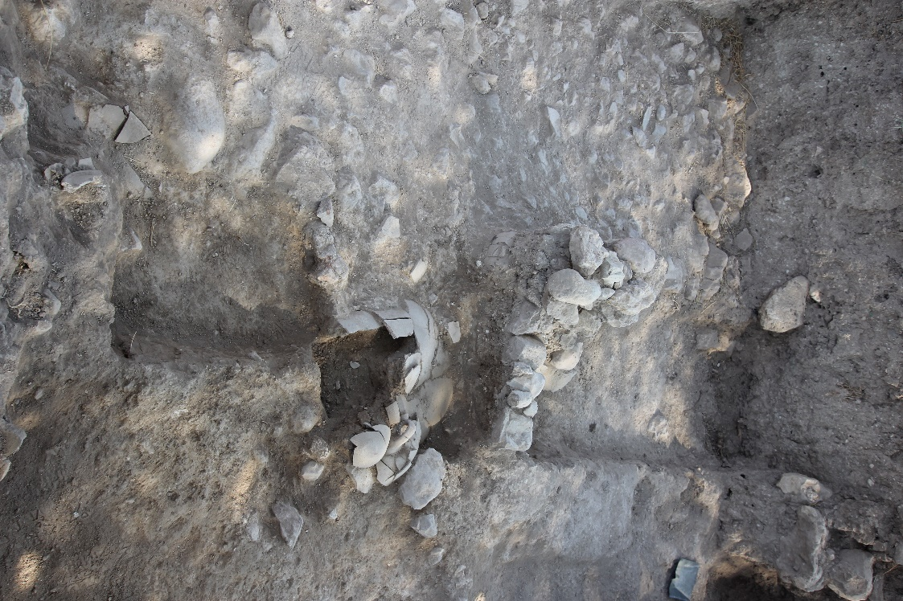
ABM19-O-033. Square H/12, pithos burial 7513, south of Wall 7510 and under bowl seen in previous photo (looking north)
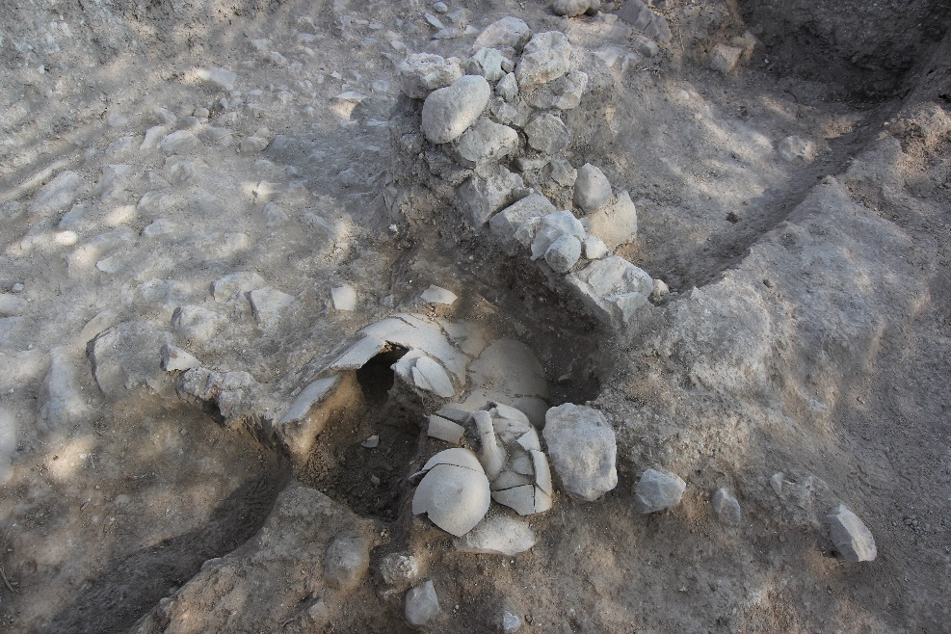
ABM19-O-45. Square H/12 looking northwest at pithos burial 7513, in relation to Wall 7510
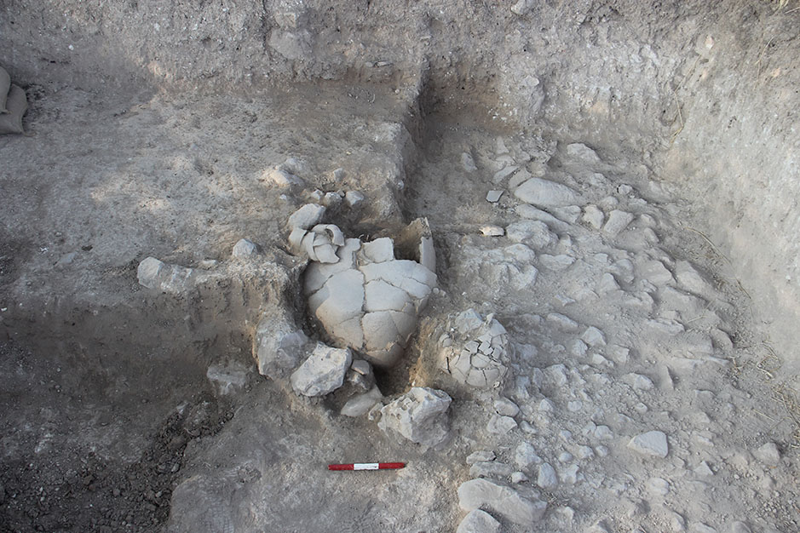
ABM19-O-058. Square H/12, looking south at pithos burial 7513 and jar burial 7516 to its west (partially on cobbles 2544); stones of Wall 7510 to the north of the pithos, near its base.
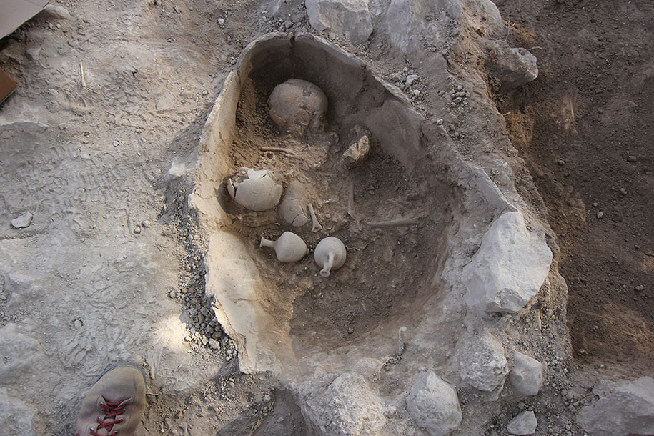
ABM19-O-070. Square H12, looking north, pithos burial 7513

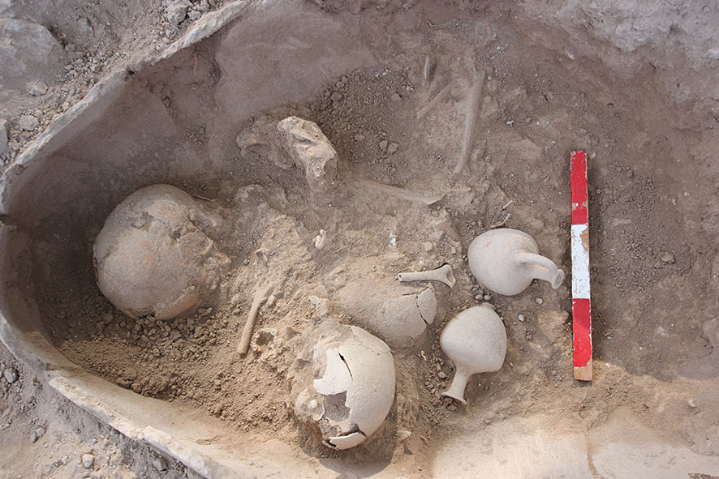
ABM19-O-075. Square H/12, pithos burial 7513

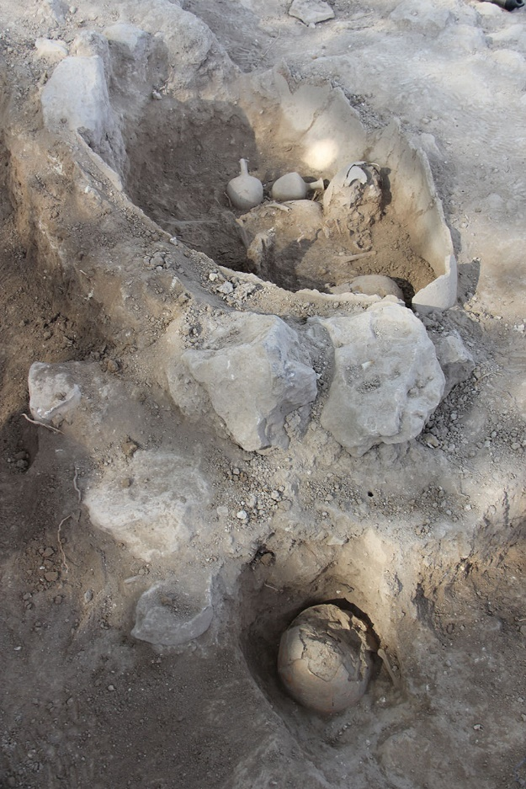Adult skull, no jar, north of pithos 7513
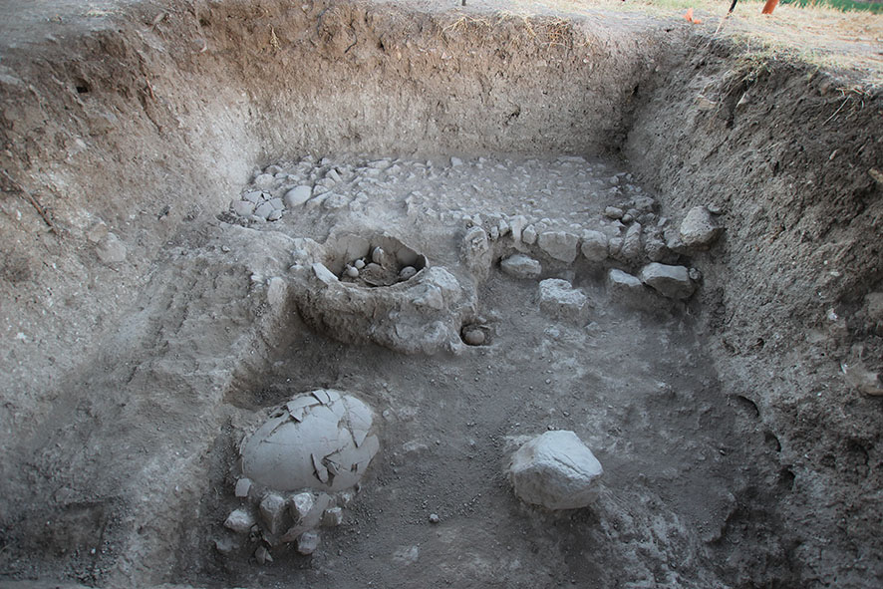
ABM19-O-095. Square H/12, looking west; partially excavated pithos burial 7513; unexcavated pithos burial 7522 to its east; skull burial 7524 north of 7513; note large stone north of 7522 (foreground center); cobbles 2544 clearly associated with burials.

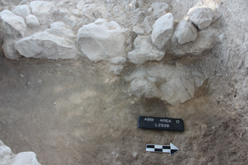
ABM2014: jar burial under/against the northern end of Wall 2547, looking west.
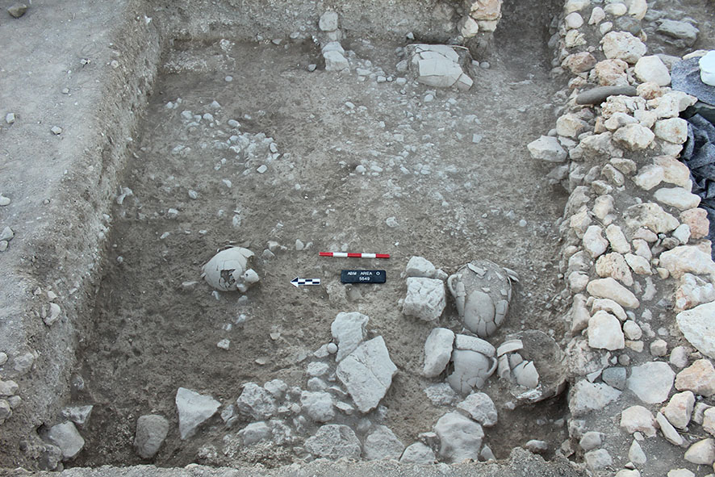
ABM2017 – img5942 (Kent) – Square I/11, courtyard 5549, looking east; concentration of burial jars in lower right, one jar in left and adult pithos burial in background.

Summary of the Burial Ground
The burial ground in Square H/12 contained pithos and jar burials, as well as an adult without a jar. Small segments of walls (2546=7510, 2547) served as markers and/or partition walls between the burials. Cobblestone layer 2544 borders the burial grounds on the west and Installation 2545 is found on a surface in the eastern end of this context. To the four burials revealed in 2019, we must add the jar burial on top of Wall 2547 from 2014; it is located to the north of Wall 7510, against the northern balk of the square.
The jar burials in Square J/11 excavated in 2017 must also be considered in light of the Square H/12 burials, although the latter appear to belong to Stratum O2, while these are assigned to Stratum O3. However, it should be kept in mind that 1) the courtyard in which the jars were found in 2017 might belong to Stratum O3 and/or 2) the phasing of Wall 2510 to Stratum O2 was based mainly on orientation, but not on direct stratigraphic relations. If this wall is to be attributed to Stratum O1, then all the jar burials would belong to the same phase, which would make sense. On the other hand, since these are burials, we may not have to consider them stratified in the same way that buildings are and they represent different episodes of burial, close in time. This remains to be further clarified.

Square I/12
The top of the balk between I/12 and H/12 was cleaned and trimmed as Locus 7504. As Square I/12 had not been excavated since 2014, much cleanup was needed (Locus 7511). Following this, a probe was conducted in the southern part of the square (7512, 7518 in the east), revealing a layer of soft debris in which ran an east-west line of stones – 7519 –preserved only one course high. It was dismantled; Locus 7520, 7521 and below them – a possible surface: 7525; one very large lower grindstone is found in this layer. It is not certain whether these remains predate Wall 2527, although the orientation of 7519, and the elevations suggest that this is an earlier phase. This will be clarified when Wall 2527 will be floating. If so, then the remains excavated this season would be contemporary with the burial grounds layer in Square H/12 (Stratum O3). No burials were found here.
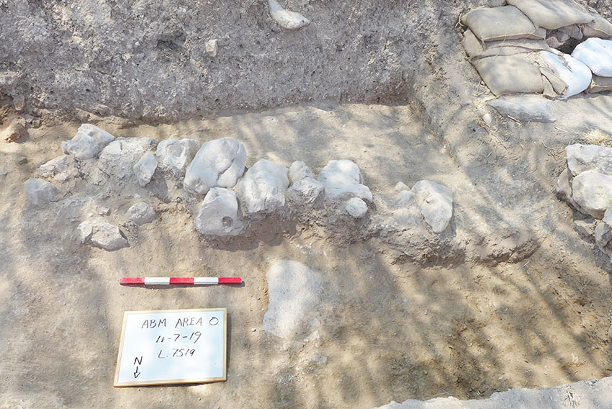
AMB19-O-1050594-Square I/11, looking north, Wal;(?) 7519; note large lower grinding stone fragment in foreground.

