Area K Field Report-2019
Alla Rabinovich
Area K is located on the eastern side of the center of the tell, just at the join between the large, flat lower part of the mound and the rise of the moderate saddle that joins the upper and lower tells (Grid square: ###; Fig. 1). A prominent spur runs along the eastern side of this saddle; it seems to begin in the north at Area A and ends in Area K. At the foot of the moderate southern slope of this spur, just below 2019 Area K, a a small area was excavated in 2015 during five days, opened due to large stones visible in the topsoil. A portion of a large wall and possible tower, as well as a sloping chalky layer related to the wall, all apparently part of a fortification, were revealed (Fig. 2). Although no pottery could be recovered relating to these walls, it is tentatively suggested that they might be the northern continuation of the Middle Bronze IIB fortification in Area F at the southern end of the lower mound.
In 2019, excavation was undertaken on the southern end of the abovementioned spur, above and somewhat to the northwest of the walls uncovered in 2015, in order to stratigraphically clarify their nature and date, as well as to investigate what caused the formation of this prominent spur. It was postulated that the late Iron Age I complex, and possibly also the Iron IIA layers uncovered in Area A to the north, continued up to here and was the reason for the hillock above the assumed MBII fortification.

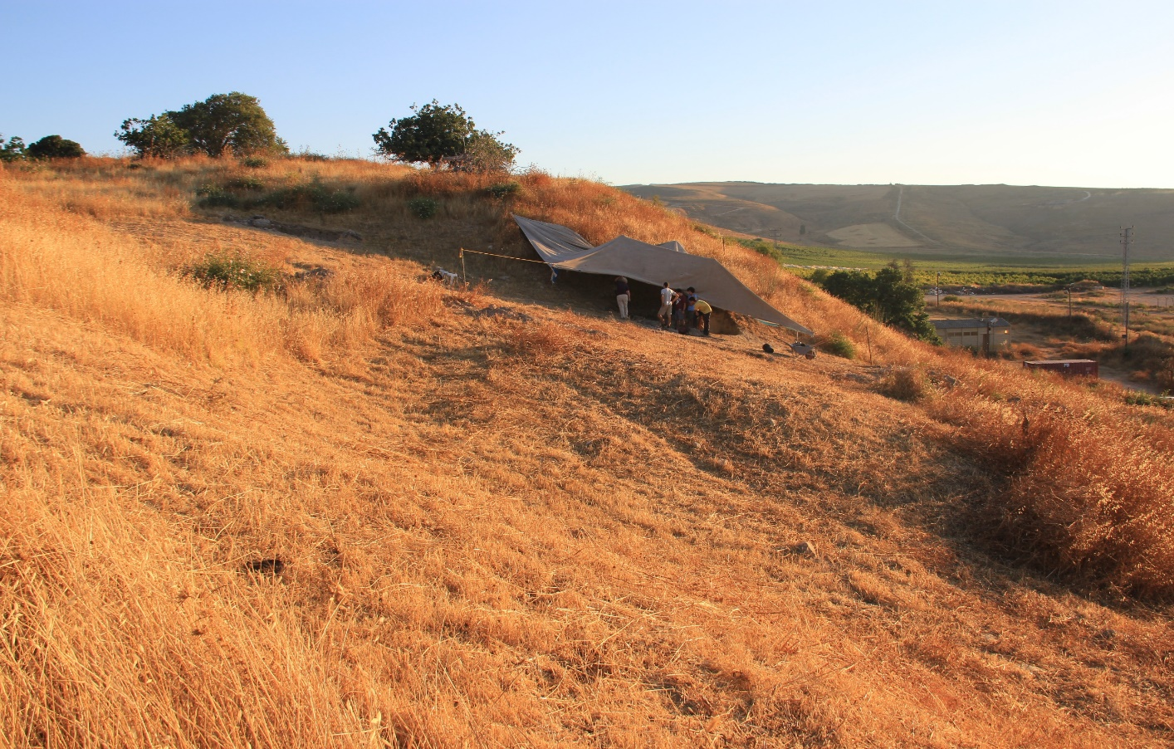

Fig. 1: Excavation in lower part of Area K, 2015, looking north. Arrow showing location of Area K in 2019. Note the elevated area above shade cloth marking the southern end of the spur that continues northwards up to Area A

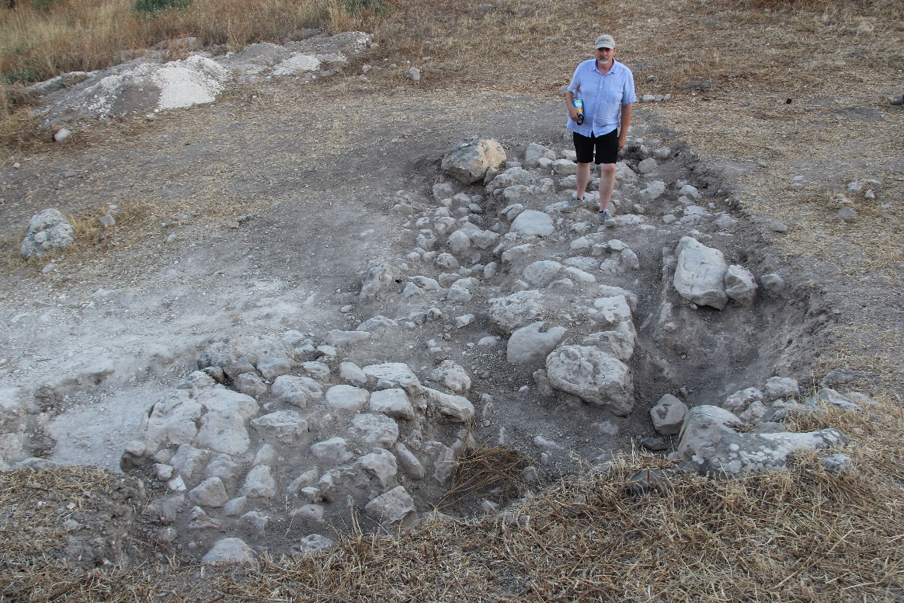
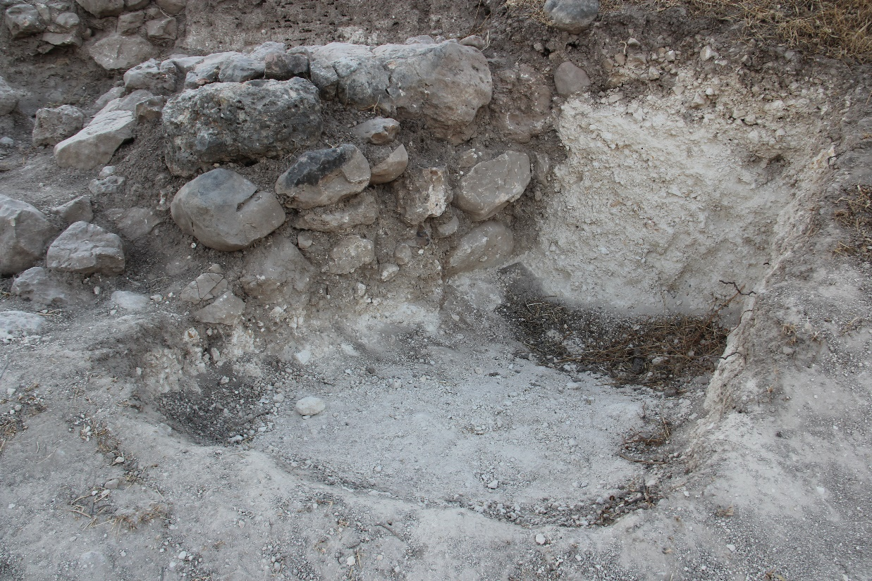
Fig. 2. Area K, 2015 (lower): Above: walls and a possible tower, looking south; Below: chalky sloping layers, possibly a rampart, extending to the east from the north-south wall, looking north

Prior to excavation, a test trench was opened by a bulldozer in the middle of the cleared area, in the southern half of Square P/5 )Fig. 3). The matrix was sterile of pottery or other finds to a depth of ca. a meter, when a layer of dark brown-gray mudbrick was revealed, interspersed with stones which turned out to be later burials. The trench was then expanded to the north, east and south in a stratigraphic excavation, covering Square P/5, the western part of Square Q/5, the north-western quadrant of Square Q/6 and the northern half of Square P/6. The excavated area amounts to ca. 55 m² altogether, including one balk between Squares P/5 and Q/5 that measures 3x0.5 m and was only excavated to the top of W7613 that crossed it from east to west. Four strata were identified: K1 including mainly late burials and several stone installations; K2 including walls and associated layers of a substantial building; K3 including a northwest-southeast stone wall and associated debris; K4 including a stone pavement and associated debris (Figs. 4–5). See Table 1 for itemization of loci and walls per stratum.
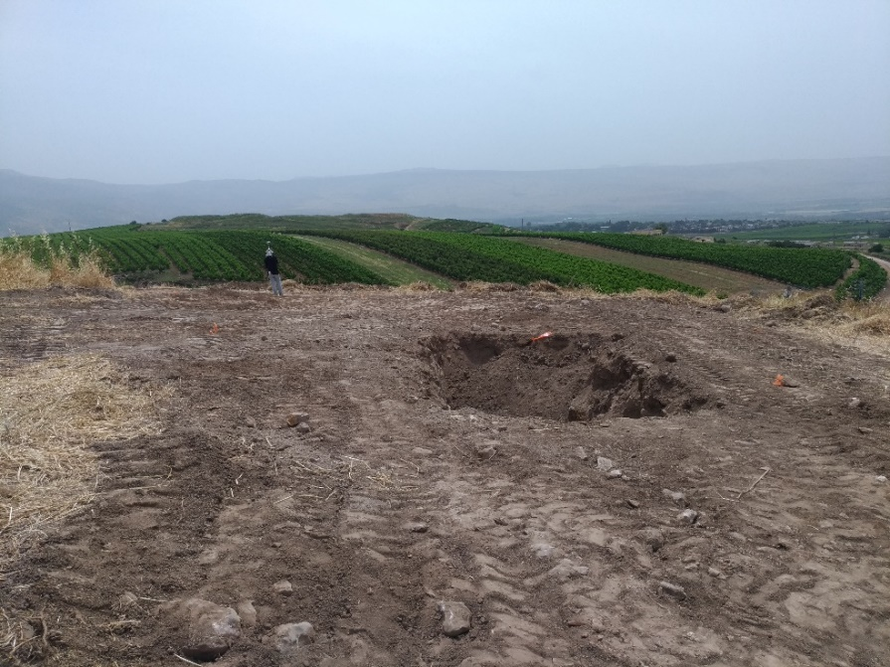
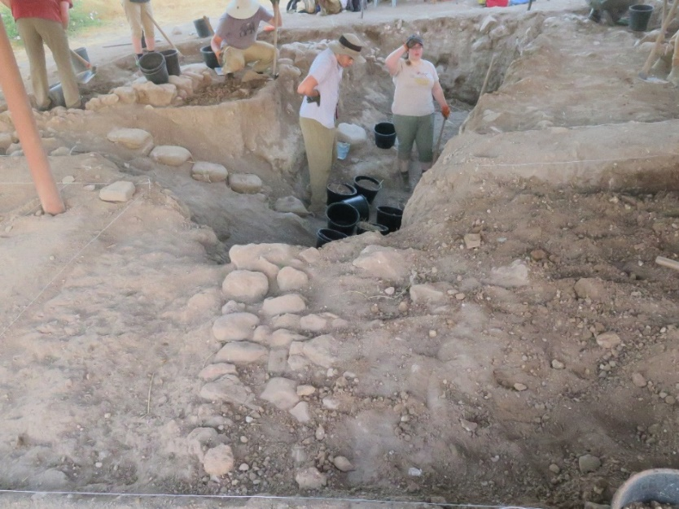
Fig. 3. Top: the test trench before excavation. Bottom: the stratigraphic excavation around the mechanical-equipment test trench

Fig. 4. Excavation area in 2019; Blue=Stratum K2; Red=Stratum K3; Pink=Stratum K4; burials and installations of Stratum K1 not shown on this plan

The topsoil was sloping down to the south and east. The topsoil level in the northwest of the area was 369.44 m, in the northeast 369.23 m, in the southwest 368.89 m, and in the southeast 368.47 m. Four local phases (K1 to K4) were discerned, as described in Table 1. Because of the fragmented nature of some of the loci, due to excavating on two sides of the test trench and piecing the information together and due to limited exposure of the earliest phase, some of the phase assignations are tentative.
The area was excavated during three weeks; the fourth week of the excavation season was devoted to documentation. Alla Rabinovich was the area supervisor, assisted in the first two weeks by Miriam Shaish. The registrar was Ella Geller in the first two weeks and then Miriam Shaish. The photos are by Robert Mullins, unless noted otherwise.

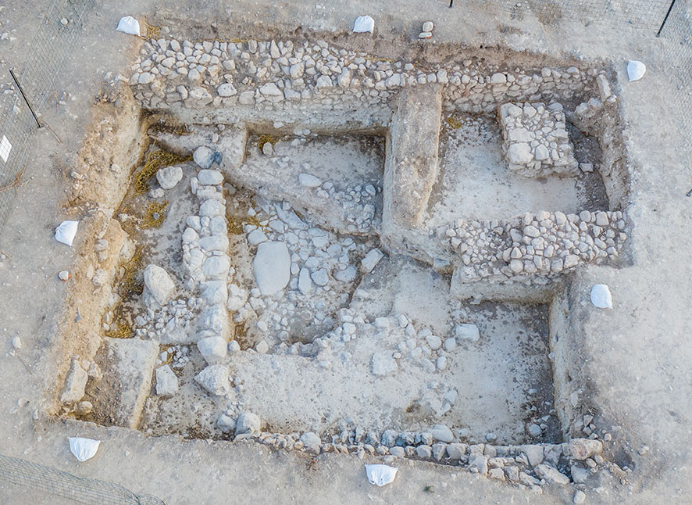
Fig. 5. Aerial photo of Area K at end of 2019 season. North on top of photo.

Table 1. Summary of stratigraphic phases, loci and walls, Area K
Local Phase | General description | Loci and Walls
Topsoil | Grey and brown loose dirt and stones | Square P/5, in the test trench  Loci: 7601  Square P/5 north of trench  Loci: 7602  Square Q/5 north of W7607  Loci: 7603  Square Q/5-6 south of W7607  Loci: 7604, 7634  Square P/5-6 south of trench  Loci: 7605
K1 | Tombs, brown fill, walls, installation, pit? | Square P/5, in the test trench  Loci: 7616, 7647  Square P/5 north of trench  Loci: 7614, 7622  Square Q/5 north of W7607  Loci: 7606, 7608, 7636, 7654  Square Q/5-6 south of Wall 7607  Loci: 7646, 7656  Walls: 7642  Square P/5-6 south of trench  Loci: 7609, 7611, 7612, 7617, 7618, 7621, 7626, 7631, 7643, 7652  Walls: 7610
K2 | Building 7613: constructional fills, walls, floors and debris | Square P/5 north of trench  Loci: 7619, 7632, 7635, 7638, 7644  Walls: 7613  Square Q/5 north of W7607  Loci: 7629, 7641, 7650 (east of Wall 7630), 7658, 7660  Walls: 7607, 7613, 7630  Square Q/5-6 south of W7607  Loci: 7639, 7649  Walls: 7648 (also in P6)  Square P/5-6 south of trench  Loci: 7624, 7627, 7645, 7653, 7655
K3 | Walls, mudbrick debris, fill? | Square P/5, in the test trench  Loci: 7633, 7640, 7651  Walls: 7620  Square P/5-6 south of trench  Walls: 7661?
K4 | Stone pavement, debris layer above | Square P/5, in the test trench  Loci: 7623, 7625, 7628, 7637, 7657, 7659

PHASE K4
The earliest element exposed this season in the area was uncovered in the center, at the bottom of the original test trench. This is 7657, preliminarily defined as a stone pavement, however the future excavation might change this definition (Figs. 6–8, 10). This is an area of about 2x3 m in square P/5, and the stones are both large and medium-sized field stones (0.20–0.60 m), along with several worked flattened stones, both limestone and basalt. The largest stone and is worked; it is elongated with one rounded end and another one flat and resembles a fallen or deliberately laid massebah. It is over 1.2 m long. Some are partly overlying others, and it is difficult to discern if these are layers or collapsed stones. The southern part of the area is generally lower and the slabs there are smaller and not so dense. A patch about 0.5 m wide (7659) to the west of the pavement and running below the K3 Wall 7620 is made up of orange mudbrick material and is interpreted as an element contemporary with the pavement. It is almost entirely devoid of stones, except for one boulder sitting right below one of the boulders of K3 Wall 7620 and looking very similar to it. It thus might be related to the construction of that wall.
The material covering these stones is a debris layer with some traces of burning; it is difficult to determine whether this is a fill or whether the partial burning is part of a widespread destruction, since the exposure is so small (Fig. 6). 7637 covered the whole area of stones 7657 and 7659, while 7625 above it has been only partly preserved after digging the test trench, on a “shelf” running along the southern and eastern borders of the trench and along the bottom of Wall 7620. 7625 contains the material above the floating elevation of the wall, including in the area immediately abutting the wall, and 7637 starts from the floating elevation of the wall down. In reality, the two loci overlapped in several places, since the matrix was hardly different, but of a very distinctive character. It contained fragments and patches of grey clay, fragments of red and orange mudbrick material, pieces of charcoal and scattered medium-sized rocks. In one area of 7637, burnt seeds were discerned and samples for flotation and for wet sifting were collected, as well as for C14 dating. 7623 was excavated in the eastern end of the test trench and later united with 7625 because of the same matrix and elevation. 7628 is a tiny area in the corner where Wall 7620 runs into the northern cut of the test trench. It was separated from all other loci and although it contained the same matrix as 7625 and 7637 and abutted the floating level and just below it of K3 Wall 7620. In the section cleaned along Wall 7620, the material below the wall looks very different, of a dark-red color. However, during the excavation this dark-red material could be discerned only about 20 cm lower than the floating elevation of the wall, it was covering the flagstones of the pavement in the eastern part of the locus. It might represent a fill laid on top of the stones when Wall 7620 and related elements were constructed, although the exposure is too small as of yet to know.
Only fragmentary pottery was recovered from this layer, mostly Iron I shapes, including pithoi rims and cooking pots. However, the area exposed is too limited to know its nature or chronology at this point.
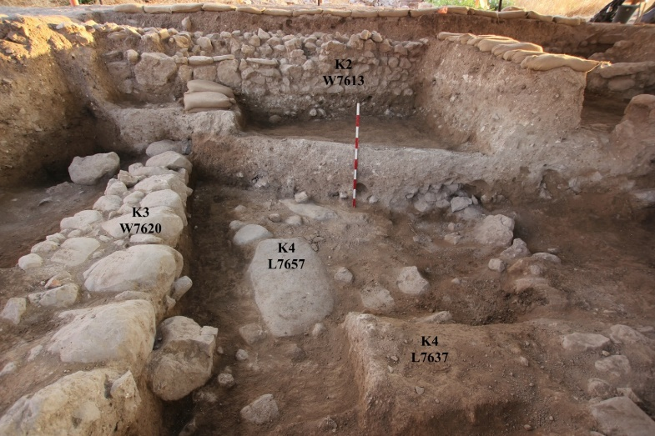
Fig. 6. ABM19-K-162, looking north. Pavement 7657 (the number is written on the large stone) is being uncovered below debris layer 7637
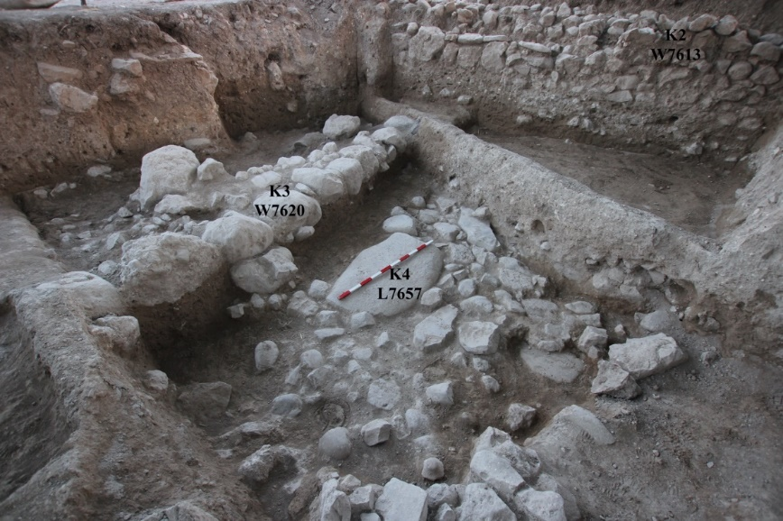
Fig. 7. ABM19-K-184, looking north-west. Pavement 7657 in the center of the area; meter tick on large “massebah-like” stone
Fig. 8. ABM19-K-266: Stratum K4 stone pavement 7657, looking east, end of 2019 season; note slabs to the north of the large “massebah-like” stone
PHASE K3
The main element in this phase is Wall 7620 running slightly northwest-southeast in squares P/5 and P/6 (see Figs. 6–10). It was uncovered over 4.5 m, both its northern and southern ends running into the balks. It is 0.75 m wide and consists of one line of limestone boulders 0.3-0.5 m large. A row of smaller stones runs along its western face in the north, while a patch of rubble and smaller stones was found along the western face of the wall in the south. Further to the west (between the wall and the balk) two large boulders were found along the wall (Figs. 8–9), and the possibility of a second line of boulders, partly robbed, was considered, but this does not seem to be the case. The area to the west of the wall is very narrow and thus conclusions are difficult to reach. There is a difference of 15 cm between the wall’s floating elevations in the north and in the south.
A possible foundation trench on the eastern side of W7620 was discerned in the northern section (Figs. 6, 10–11). Another possible indication of a foundation trench is how the K4 pavement 7657 terminates some 40 cm to the east of Wall 7620, suggesting it might have been cut. It is preliminarily suggested that the foundation trench was excavated into the debris of K4 and then backfilled with the same material. Further expansion of the earliest strata in this area might provide a better explanation. Notably, the material above (7625) and below the floating elevation of the wall (7637) in this area and also further to the east was the same; as noted above, this matrix might be a fill.
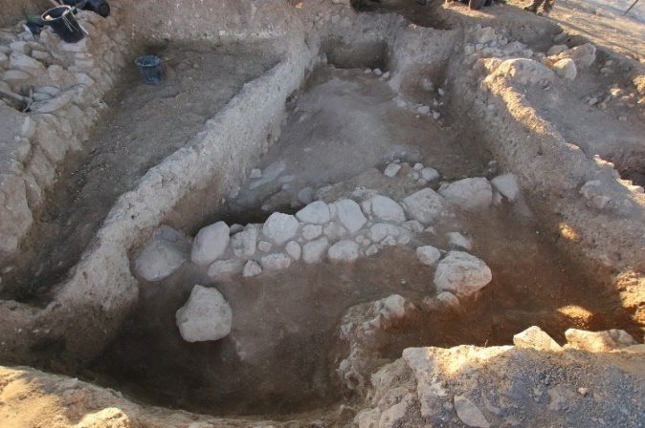
Fig. 9. ABM19-K-058. Wall 7620, looking east.
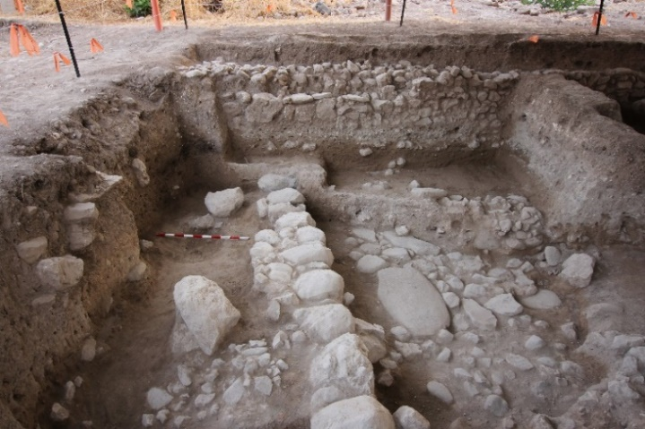
Fig. 10. ABM19-K-238. Wall 7620, looking north; note layer of stones along the western face of the wall in the south (lower left corner) and two boulders to the left (west) of the wall
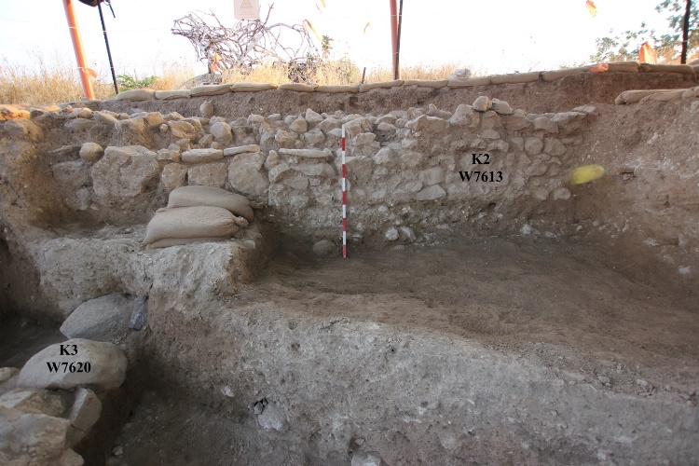
Fig. 11. ABM19-K-145, looking north. Note the dark patch - foundation trench? to the east of W7620 in the balk
On the eastern side of the wall, there were no major elements that we could assign to the phase of the wall. It is not yet clear whether this was an open area outside of the building, or inside a room. Maybe some of the scattered medium-sized rocks found there, in 7625 and 7651, belong to that phase (Fig. 12). The area on the western side of the wall was excavated very little. 7633 along the western baulk was possibly a stump of a mudbrick wall or mudbrick debris that continues into the unexcavated area. In 7640 to the west of the wall, the excavation was very shallow since the purpose of the work here was just to check if there is another row of slabs to the wall. The nature of this locus is not clear as for now.
The top of an east-west stone wall, 7661, was uncovered in the south of the area, running below K2 Wall 7648 (Figs. 11–12). Based on the elevation and the direction of the wall and the character of the stones, it is proposed that it had originally cornered with Wall 7620. However, this is tentative and needs further clarification.
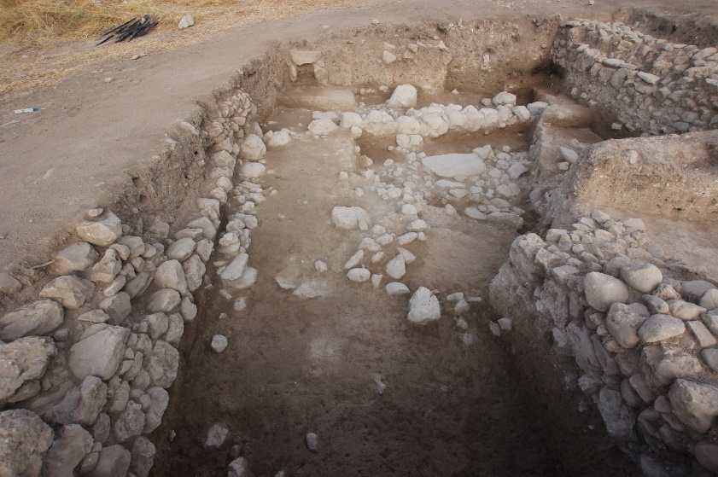
Fig. 11. ABM19-K-263. Looking west; possible corner of Walls 7620 and 7661 in upper left of photo; note K2 Wall 7648 above Wall 7661; Note the scattered stones and debris (7651) in the center.
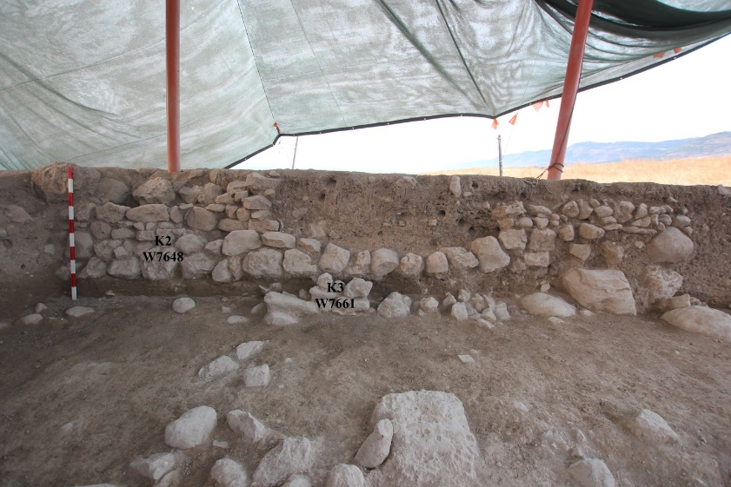
Fig. 12. ABM19-K-232, looking south. K3 Wall 7661 under K2 Wall 7648 (cut by late burial 7646 -where two courses are preserved and by burial 7643 where one course is preserved).

PHASE K2
This is the most prominent stratum uncovered in the area, with its main feature being Building 7613. The architectural remains were revealed under topsoil, although they were cut by late burials. This building is comprised of three east-west walls and one short north-south wall; a surface with storage jars was discovered in the northeastern part. A pre-construction phase was identified, visible mainly underneath the northern wall and somewhat less so under the other walls.
Pre-Construction Phase
Covering the scattered stones and debris of K3 in the center of the area, and reaching north to run below K2 Wall 7613, was a layer of dark brown sediment and varying amounts of crushed limestone. This appears to be some kind of levelling fill laid in preparation for the construction of the K2 building: 7639, 7649 in Squares Q/5 and Q/6 between and below Walls 7607 and 7648 (Figs. 13–14); 7645, 7652, 7655 in Squares P/6 and Q/6 in the south, running below Wall 7648. These loci contained large amounts of pottery, Iron I and Iron IIA, but also some MB and LB. Some of the stones of layer 7651, attributed to K3, might belong to this fill as well.
This layer was overlaid by another layer fill of different character and much patchier a – hard light-brown material that came out in chunks and fell apart into sand when excavated (7624, 7627, 7653). This kind of material was encountered only in the southern part of the area, mainly on both sides of W7620 and on top of it, becoming increasingly thin towards the east (to the west of Wall 7620 it was not encountered). It might contain remnants of eroded brick that was in the superstructure of Wall 7620. Its excavation was fragmented and complicated by numerous tombs of K1 that penetrated the layers all the way down almost to the top of Wall 7620.
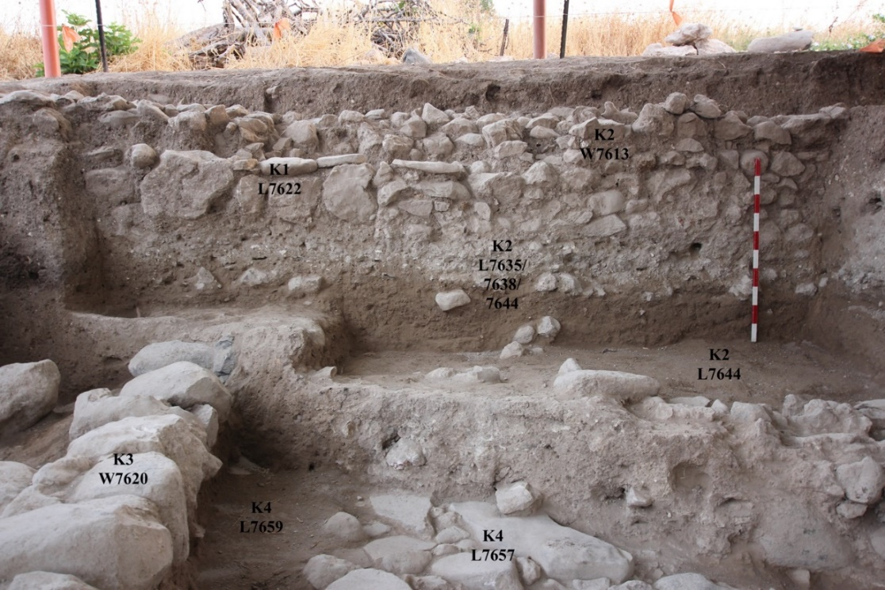
Fig. 13. ABM19-K-236, looking north. K2 Wall W7613 (cut by late burial 7622 on the west) and constructional fill 7635/7638/7644 below it in the section
Fig. 14. ABM19-K-234, looking north-east. K2 Wall W7607 and constructional fill 7639/7649
below it in the section

Construction Phase
Three parallel walls, 7613, 7607 and 7648, run east-west at a slight angle to the grid (Figs. 15–16). The floating level of each wall is lower according to the natural slope southwards; thus, Wall 7613 on the north floats at 368.40 (on the east and 368.17 on the west), Wall 7607 floats at 368.00 and the floating level of Wall 7648 is 367.65. A short segment of a north-south wall, 7630 extends south of Wall 7613 near its eastern end.
Fig. 15. Walls of Building 7613. In plan, stars mark location of the storage jars
Wall 7613 runs along the northern balk throughout all excavated area and continues to the east and west beyond the limits of the excavation (Fig. . Its northern face is still inside the balk in the north-eastern corner, so that at the eastern end, only its outer southern row has been unearthed. It is 8 m long and 1 m wide. It is preserved to 6 courses of field stones about 0.2-0.3 m large. The wall is constructed of two outer rows of stones 0.2-0.3 m large with rubble in between. Its bottom elevation is lower by about 25 cm in the eastern end, apparently in accordance with the natural slope. The wall was cut by late burial 7622 in square P/5 (Fig. 13). The northern side wall of the burial made up of large boulders was inserted into the wall, replacing its southern face.
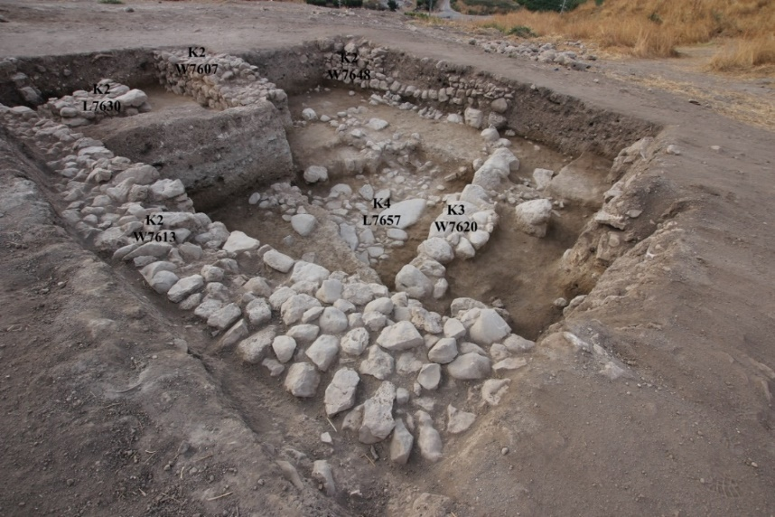
Fig. 16. ABM19-K-270, looking south-east. Three parallel walls of K2 Building 7613 (7613, 7607 and 7648) running east-west and Wall 7630 abutting Wall 7613 in the top left
At the eastern end of Wall 7613 near where it enters the balk in Square Q/5, the wall makes a corner with a short north-south stone segment that we identify as a wall, 7630 (Figs. 15–18, 21), although it was originally thought to have been some kind of platform due to its very straight sides. A late burial -7606 - used Wall 7613 as its northern wall and cut into Wall 7630, heavily damaging the corner between the two in its upper courses (Figs. 17–18, 21); the corner between 7613 and 7630 is visible only at the bottom course which actually served as the bottom/floor of burial 7606. Wall 7630 is 1.5 m long and 1.1 m wide and consists of three courses. It is constructed somewhat similarly to Wall 7613, with large stones around the edge and smaller stones in the middle. Its southwestern stone is particularly large. Notably, the bottom course of 7630 seems to be somewhat narrower than the upper courses, so that from the west, it is floating (at 368.30) but from the east it is not yet. However, this needs to be further clarified.
At a distance of 2.4 m to the south of Wall 7613 in square Q/5, with 0.9 m separating it from the southern end of Wall 7630, runs Wall 7607 (Figs. 15–16), 3.15 m long and 1 m wide, preserved to 4 courses of field stones 0.15-0.3 m, built in a technique similar to that of Wall 7613 (outer rows of larger stones and rubble in the middle). However, the bottom course of Wall 7607 (made up of stones 0.3 m large) is distinctively more neat and substantial than its upper courses (stones 0.15-0.2 m), whereas the courses of Wall 7613 all look similar. Wall 7607 is short and it was not encountered in the test trench. Thus, either it was originally of this length, or it was cut in later periods. The upper courses of the wall have been cut by a late burial - 7636. On the floating level of the wall, in the debris to its south, (7634) we found a scarab (76198), apparently to be dated to the Late Bronze Age and thus not in situ.
At a distance of 2.6 m to the south of Wall 7607 runs Wall 7648, at the same angle and apparently of a similar construction, but for most part still concealed in the southern balk (Figs. 12, 15–16). Its bottom elevation is 35 cm lower than that of Wall 7607 (367.65). The uncovered length of the wall is 3.7 m and the maximum width uncovered so far is 0.5 m. It is preserved to the maximum of 4 courses (but only 1 or 2 courses throughout most of its length) of fieldstones 0.2-0.25 m large. Even in the relatively small part that was uncovered, it was heavily disturbed by two burials that cut into it (7646 and 7643). As noted above, it was built above K3 Wall 7661.
Habitation Phase
In Building 7613, remains of occupation in the form of a floor and vessels on it were only found in square Q/5, in the rooms formed by Walls 7613, 7607 and 7630. Five complete restorable storage jars were found in loci 7629 and 7650 (see Figs. 17–22). Three jars were found against the northern face of Wall 7607, resting on beaten-earth floor 7641: one (76138, Locus 7629) near the western end of the wall, one (76147/76157, Locus 7629) in its center, opposite Wall 7630, and one (76372, Locus 7629) just where the wall enters the eastern balk. Two others (76376, 76385 [and other baskets], Locus 7650) were found along the eastern face of Wall 7630, in a narrow area exposed between it and the eastern balk. One of these jars bears an ink inscription and has a cross-shaped potter’s mark on one handle (Fig. ##). One jar contained dark residue in it base among which was a grape pip.
Fig. 17. ABM19-K-213, looking west. 1-3 – findspots of three restorable jars against northern face of Wall 7607. No. 3 is still in situ (see next photo for Nos. 1 and 2). To the north of Jar 3, against the eastern face of Wall 7630, another two jars (4 and 5) – Locus 7650, against the eastern face of Wall 7630. The northern of these jars is covered by the stones of the southern side wall of late burial 7606.
Fig. 18. ABM19-K-070, looking east. Right: the western (no. 1) and middle (no. 2) restorable jars found in Locus7629 against the northern face of Wall 7607.
Fig. 19. Left: ABM19-K-218. Detail of jar No. 2 looking southeast; Right: detail of jar No. 1, looking southwest
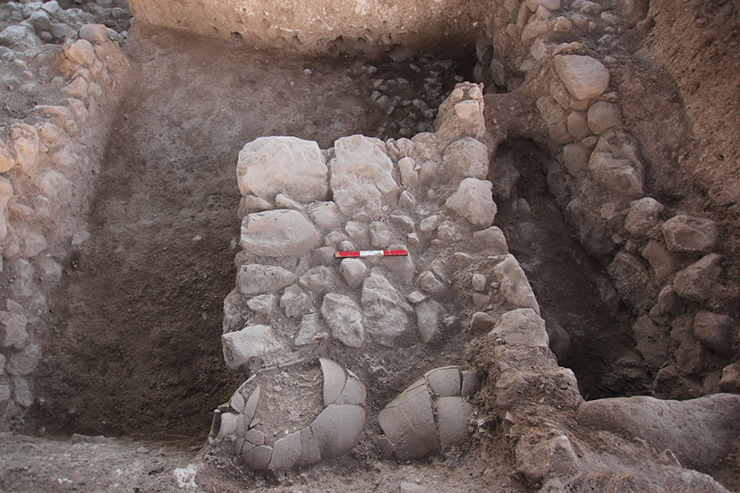
Fig. 21. ABM19-K-207. The two jars in 7650 (4 and 5 in Fig. 22#), against eastern face of Wall 7630, looking west; cut of late burial 7606 on the right
Fig. 22. Stratum K2 Building 7613 with location of storage jars (see Figs. 17–21). 1=76138 (7629); 2=76147/76157; 3=76372 (7629); 4=76376 (7650), 5=76385 (7650). No. 4 is the jar with the inscription. No. 5 is the jar with the grape pip.

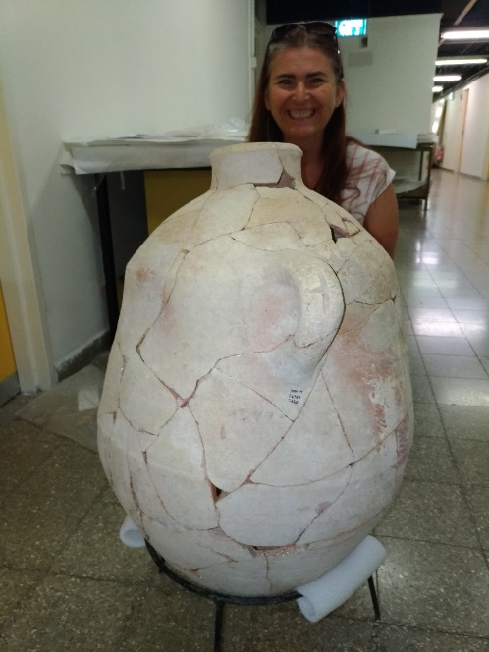
Jar 4 with the inscription. Restorer-Adrianne Ganor

The vessels and the floor between them were covered by a thick layer of plaster, possibly a fallen ceiling or roof 7660, or possibly plaster from the walls (Fig. 23). A round-contoured line composed of tabun-like material (unnumbered) was found below the two jars in 7650. Remains of such material, perhaps another tabun, seem appear below the western floating level of Wall 7630. The jars were resting on the earthen floor 7641 that covers most of the area. Debris 7629 is the layer above this surface throughout much of the room and 7650 was assigned to the same layer but to the east of Wall 7630 and thus, in another room. During the excavation of 7641, next to Wall 7613, a patch of a cobbled surface 7658 was uncovered (Figs. 23–24). 7658 abuts the floating level of Wall 7613, although since the floating level of this wall is somewhat higher to the west (west of the balk), it might be earlier than the wall. It thus is not yet clear whether 7658 should be attributed to the K2 occupation context of Building 7613– possibly as part of floor 7641 – or whether it represents an earlier phase. The stones continue to the west into the balk (although they were not detected to the west of the balk), but there is a gap between them and the western face of Wall 7630, which appears to be floating here. It is not yet clear whether they continue to the south or not. Further excavation in the area to the south of stones 7658 will determine this.
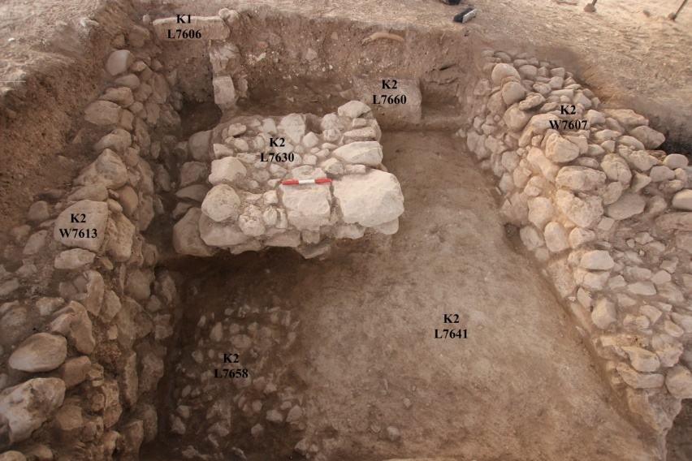
Fig. 23. ABM19-K-245, looking east. Northeastern part of Building 7613 (end of 2019 season). K2 Wall 7613, with cobbled surface 7658 abutting it?; Wall 7630 cut by burial 7606. 7660 -layer of plaster in the eastern section.
Fig. 24. Top-ABM19-K-251. Looking north, late burial 7606 in upper right corner; Bottom-ABM19-K-195, looking northeast. Stone patch 7658 in relation to Wall 7613. Balk between Squares P and Q/5 on the left
Aside from these five complete, broken storage jars, no other restorable vessels were found in the rest of the room to the west delineated by Wall 7613. A balk was left between Squares P–Q/5. It is notable that while the eastern part of the room within square Q/5 to the east of this balk had a distinctive reddish-brown debris layer (7629) above the floor (7641), on the other side of the balk in square P/5, at the same elevations that define 7629/7650 with the jars (~368.7 and 368.24), were two consecutive layers of different character abutting the southern face of Wall 7613 (Fig. 25). The lower layer was 7632 (368.10-368.45) that consisted of a brown fill (lacking the reddish shade of 7629). The upper one was 7619 (368.37–368.60) that started at about the same height as 7629 (lower level=368.26) and was a hard grey layer with numerous white inclusions that might possibly represent a surface. 7619 abutted Wall 7613 at about the third course (Fig. 25). A rim of a storage jar was “restored” in the field from three fragments that came from 7629, the bottom basket of 7619 and the first basket of 7632. Patches of white material were noticed in 7629 but not as a substantial layer like in 7619.
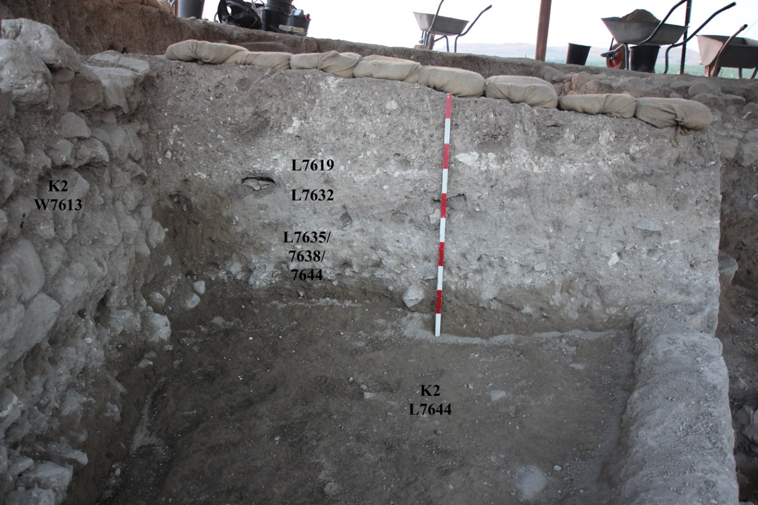
Fig. 25. ABM19-K-190, looking east. Western face of the balk between Squares P/5 and Q/5. 7619 is seen as a white stripe in the middle of the section.
Fig. 26. ABM-K-240. Balk between Squares P and Q/5 – looking west. Eastern face of the balk.

PHASE K1
The latest activity in the area was dominated by cist tombs and burials, tentatively dated to the Ottoman period. Seven massive constructed tombs (L7606, L7609, L7617, L7621, L7622, L7631 and L7646) and at least four cases of open burials (L7614, L7636, L7643 and L7656) were found in the area. Many of them made use of the walls of K2 that were partly dismantled as a result.
Most of the cist graves were about 2 m long, covered with elongated capstones about 0.7-0.8 m long and about 0.3 m wide. The width between the walls of the tombs was about 0.35-0.45 m. The walls were constructed either of flat slabs standing on their narrow sides, or of field stones arranged in one or two courses, unless an existing ancient wall was used as one or both of the side walls. For example, Tomb L7606 used W7613 for its northern wall, and L7630 for its southern wall and the bottom. For that purpose the upper courses of L7630 abutting W7613 were partly dismantled (Photos 10-12). Tomb L7622 also cut W7613 but in a different way: for the northern side wall, part of Wall W7613 was dismantled and a row of field stones was inserted instead, restoring the southern face of the wall (Photo 7). L7646, a tomb of a baby or a young child, cut W7648, the upper courses were dismantled, the body was placed on the remaining courses and covered with capstones. Other tombs were constructed from scratch (Photo 15).
Below the adjacent Tombs L7609 and L7617 was a thin layer of yellow sandy soil, possibly placed intentionally at the bottom of the tombs. It was not discerned below other tombs.
The open graves in three cases (L7614, L7636 and L7656) were very shallow remains found close below the surface. L7614 was found south of W7613 and was built of two rows of field stones, without capstones. L7636 cut into W7607. Another burial was found in the topsoil in square Q/5 and was so disturbed that it was not even given a locus. L7656 is a skull found in the eastern baulk, so the rest of the body remains unexcavated. But it is clear that it is not buried in a cist tomb. The fourth case, L7643, is different. It was an articulated and well-preserved body but it probably had no grave of its own and was not covered with capstones. Upon partly dismantling W7648, it was laid on that wall’s bottom course, stuffed in between the southern wall of Tomb L7631 and possibly another grave still in the southern baulk (Photo 16).
In all cases where the skeletons were found in articulation, they were oriented east-west, with the skull in the west. In most cases, where it was possible to determine that, they were facing south. However, in L7622 the skull was facing upwards, and in L7606 the skull was facing up and to the north, at a ¾ angle. Petrous pyramids, teeth and fingers were collected from most of the skeletons.
Most of the tombs, even the massive ones like L7606, did not contain any burial gifts. The exceptions were the graves in the south of the area. Tomb L7631 probably contained a bronze ring (B76287), although it was found outside of the tomb. Burial L7643 contained a bronze ring decorated with a bead (B76269). Burial L7646 contained two iron bangles (B76274).
W7610 ran east-west between Tomb L7621 and Tomb L7631, its floating elevation was just above the top of the tombs (Photo 17). It was 2 m long and 0.5 m wide. It consisted of 2 courses of field stones of up to 0.5 m large, in one row, and rubble. W7642 ran east-west between Tomb L7631 and the eastern baulk, where possibly another tomb starts. It was 2.4 m long and 0.8 m wide. It was built of 1 course of fieldstones in two rows. Unlike W7610, the top of W7642 was perfectly aligned with the top of the capstones of Tomb L7631, so that only from the side it was possible to discern between them (Photo 18). Despite this difference, both walls seem to be relating to the tombs. They are later than the tombs, at least in terms of constructional phases. They probably represent some feature of the graveyard.
The tombs were cut into brown fill excavated as L7608, L7611, L7612/7626, L7618, L7652 and L7654. L7616 was opened for the brown fill found when straightening the slopes of the test trench, it was mixed with the topsoil.
L7647 was opened for the soft fill encountered at the bottom of the test trench, it was the first locus excavated in the lowest part of the trench (apart from L7601 that contained the loose dirt left after the bulldozer). It contained mixed material, including the only one Rashid al-Fuhar sherd found in the area. It could possibly belong to a later trash pit dug here, which was not otherwise identified.
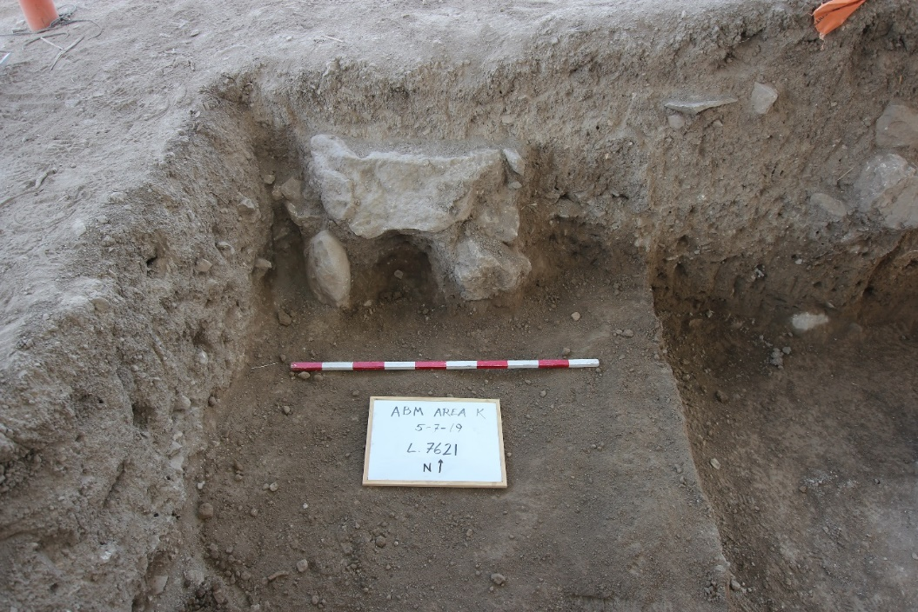
Photo 15. ABM19-K-097, looking west. Remains of Tomb L7621 (a capstone and the side walls), protruding from the western baulk.
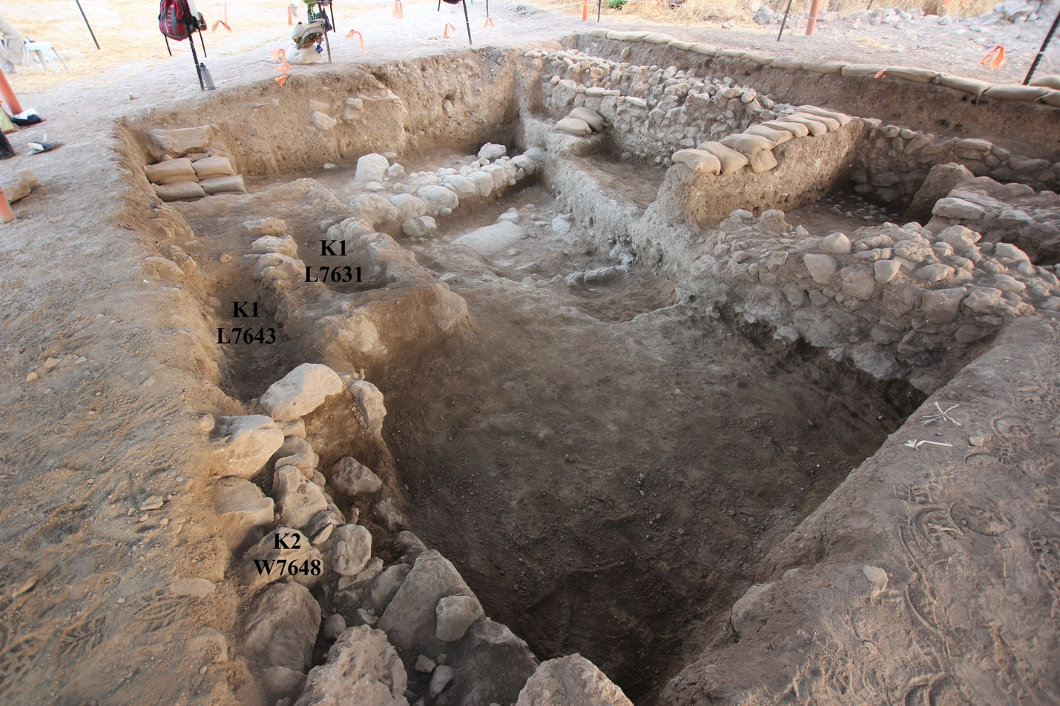
Photo 16. ABM19-K-124, looking west. Burial L7643 between Tomb L7631 and the southern baulk, above the continuation of K2 Wall W7648.
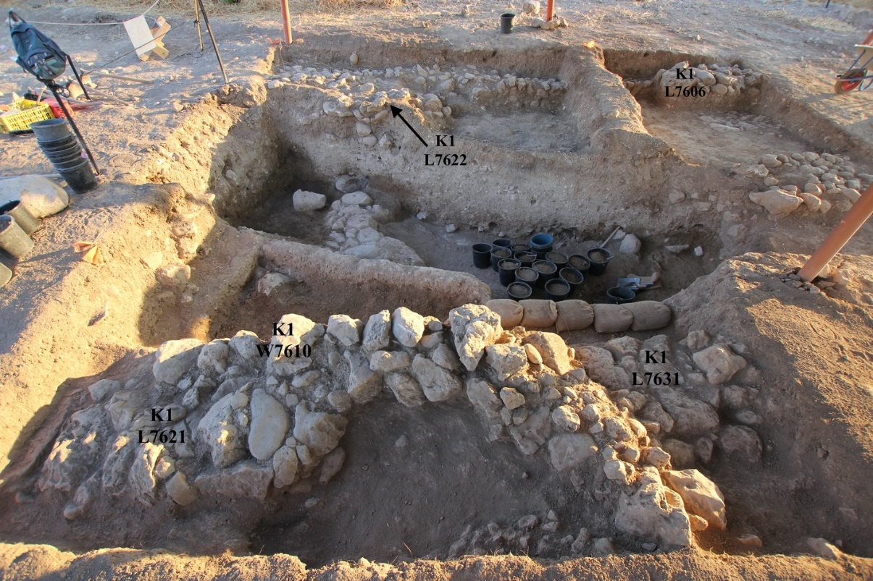
Photo 17. ABM19-K-049, looking north. Wall 7610 running above burials 7621 and 7631.
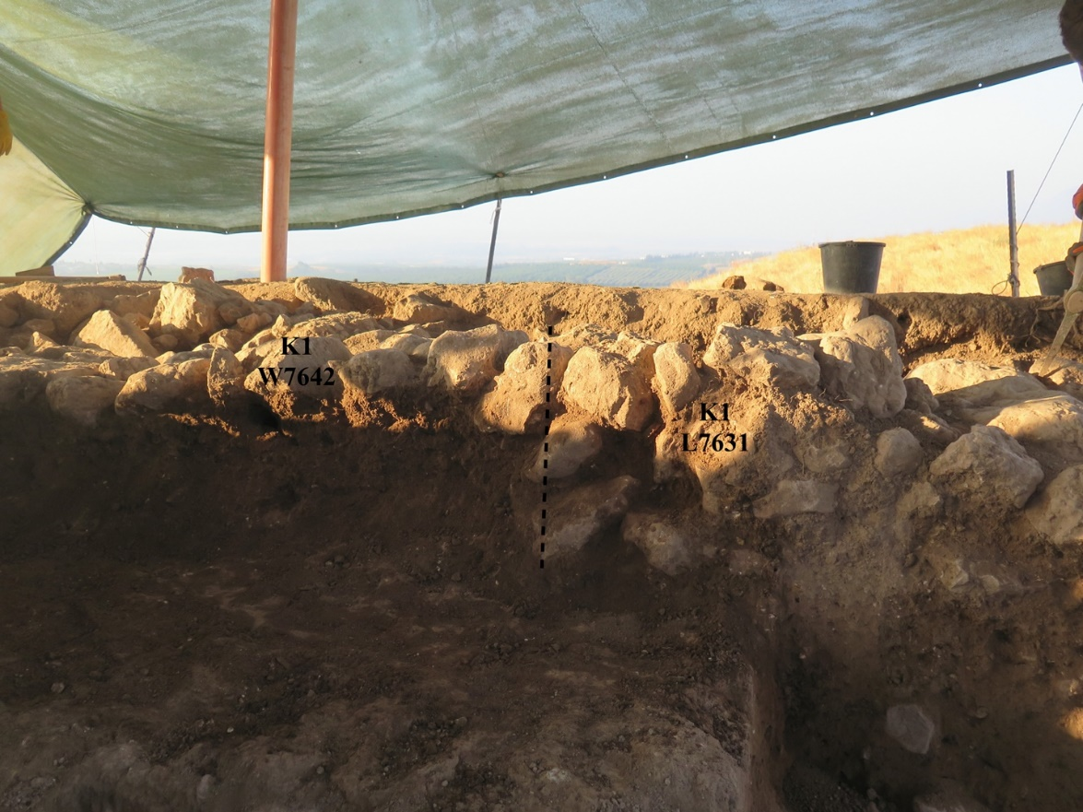
Photo 18. Looking south. Tomb L7631 and floating Wall W7642. Photo by Alla Rabinovich.

